Fire Districts – General Overview: (Borrowed heavily from Town of West Barnstable, MA)

Fire Districts are quasi-municipal governments that provide fire protection, fire inspection & code enforcement, and emergency medical services (EMS).

Fire districts aren’t the only kind of districts found in Massachusetts. There are water districts, electric light districts, recreation districts, road districts, sewer districts and refuse districts. In total, there are 144 local districts of varying types in Massachusetts. (Special Taxing Districts)

Special Taxing Districts are quasi-municipal governments that have their own elected officials, bylaws, and taxing authority. Special Taxing Districts are limited to a scope of services defined by the state legislature. There are currently 144 Special Taxing Districts and 26 Fire Districts in Massachusetts.

Fire districts are created by the Commonwealth and not by a city or town. Fire districts are created only when a city or town chooses not to organize a fire department. According to General Law Chapter 48 Section 61, before a fire district can be created the town must consider a petition to create a fire department at a town meeting and refuse or neglect to so do. If the town chooses to create a fire department, then no district can be created. This procedure dates back, in one form or other, to 1844.

A fire district is governed by a district meeting that is similar to an open town meeting. Each fire district has a moderator who has the same powers as a moderator in towns with a town meeting (GL Chapter 48 Section 66).

Fire district executive authority is given to a prudential committee. Prudential committees are roughly the equivalent of a combined board of selectmen and finance committee from a town form of government. According to GL Chapter 48 Section 71, the prudential committee “shall expend, for the purposes prescribed by the district, the money so raised or borrowed, and shall choose a treasurer. This means that the prudential committee must use its money only for the purposes of the district. For instance, they can’t use district funds to pay for playgrounds, schools, roads, or other non-fire/EMS/water purposes, unless authorized by the legislature.

Fire districts raise money through property taxation (GL Chapter 49 Section 69) “for the purchase of engines and other articles necessary for the extinguishment of fires, for hydrant and water service, for the purchase of land, for the erection and repairs of necessary buildings, for the erection and maintenance of street lamps within their limits, for the purchase, operation and maintenance of ambulances .” The power to purchase ambulances was added to the law in 1950.

Fire districts may also collect fees for certain services, typically ambulance fees and inspection fees.

Once a fire district is legally established then the fire district creates a fire department by appointing a chief engineer (think “fire chief”) and “as many assistant engineers, enginemen, hosemen, and hook and ladder men as they may consider necessary. ”The law limits these appointments to no more than seventy-five (75) per engine and twenty-five (25) per hook and ladder. You can also have five hosemen for each 150’ of hose.

Over the years, each fire district in Massachusetts has evolved into slightly different structures. Some have both a prudential committee and fire commissioners, while others combine the two). All of these changes come from legislative authorizations and/or from bylaw changes voted at annual fire district meetings.

While Massachusetts doesn’t have many fire districts compared to its total number of fire departments, fire districts are more common nationally. In some states like Pennsylvania, the fire district is the more common form of organization of fire departments. Connecticut has a great many fire districts, as does Rhode Island.

Fire Districts – South Hadley (from 2024 PVPC report):

In addition to its municipal government, South Hadley also contains two Fire Districts which provide fire, ambulance, and water service throughout town, as well as a small portion of the Towns of Granby and Ludlow. Fire Districts 1 & 2 are distinct governmental organizations that operate independently from the Town, although there is a good deal of coordination and cooperation that takes place between the various entities. Fire and ambulance service is funded by a combination of property taxes, ambulances receipts, grants, and fees. Water service is funded primarily by water receipts from businesses and residents.

The following map delineates the overall service area of each District

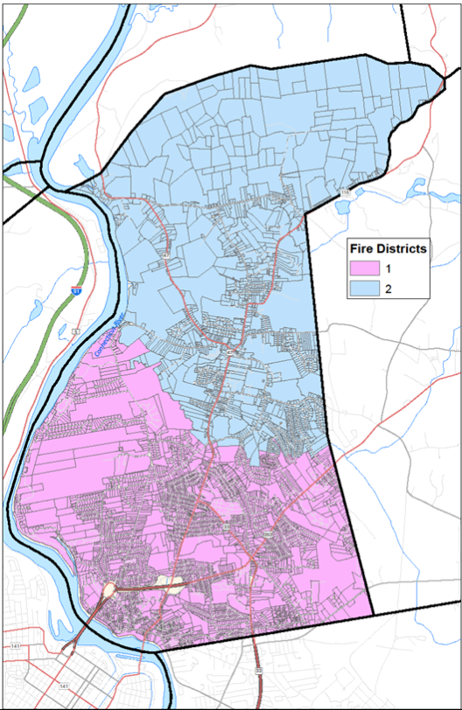

Both South Hadley fire districts operate as independent and distinct governmental entities. Chapter 48, Section 60 of Mass General Law authorizes the creation of fire districts, with subsequent sections and chapters of MGL defining how a district is formed, governed, and operated. In Massachusetts fire districts are considered “quasi municipal corporations” and hold many of the same authorities as cities and towns, including the ability to levy property taxes and fees to pay for fire protection and inspectional services, and water bills to pay for water service.
Each district is governed by a 3-member Prudential Committee and 3-member Board of Water Commissioners, elected by the registered voters of the districts each Spring in conjunction with the Town election. All meetings of the prudential committees and water commissions are public meetings under Mass General Law and subject to the Open Meeting Law.
The Prudential Committees are charged with overseeing the operations of their respective fire and ambulance departments and the water commissioners oversee their respective water departments. The Prudential Committee are also responsible for creating a warrant (agenda) for the Annual District Meeting each Spring, normally in May. The warrant is made up of various articles requesting the appropriation of funds that comprise the annual budget for each department. The warrant may also include requests for changes to the district’s bylaws and other requests related to the general operation of the district. From time to time throughout the year, Special District Meetings may be called to deal with issues or requests that arise. All registered voters of the district are allowed to vote at any annual or special district meeting. The District Moderator is charged with running all district meetings.
Additional elected positions of the districts include the Clerk Treasurer of District 1 and District Moderators in both districts. Of note, District 2 made the decision in 2014 (effective in 2015) to change the Clerk Treasurer from an elected to an appointed position. This change was made just three years after the Town took the same action regarding its Clerk, Treasurer and Collector positions. District 1 has considered taking similar action, but has yet to do so.
As mentioned above, the districts levy taxes and charge fees for various services. Once the district department budgets are appropriated at the Annual District Meeting, and the fiscal year is closed out, the tax rate is determined for the following year – typically in early December at a joint meeting of the South Hadley Selectboard and both Prudential Committees. Leading up to that joint meeting, the Town’s Associate Assessor assists the District Clerk Treasurers in completing the previous year filings with the State Department of Revenue, which is critical in establishing the tax rate. District taxes are subsequently billed and collected in coordination with the Town Collector Treasurer.

Fire District 1 was first organized within the Village of South Hadley Falls in 1858. The village, which roughly encompasses the southern two-thirds of the Town of South Hadley, struggled with providing a consistent water supply to all residents, particularly in the hillier portions of the district. In 1872, the district took action that resulted in authority being given by the State Legislature to establish a more robust and comprehensive system of waterworks. This special legislation, known as the Acts of 1872, Chapter 114, authorized the district “to supply itself and its inhabit with pure water to extinguish fires, generate steam and for domestic and other purposes; and may establish public fountains and hydrants, and regulate their use and may discontinue the same and may fix and collect rents for the use of such water.” Further, this legislation gave the district the authority to establish centralized water sources, create damns, dig up roads, take property, and issue bonds. Several additional special legislative acts have been sought and approved over the years which have served to expand and/or clarify the authority of the district.
Following a major fire in 1896 at the seminary building at Mount Holyoke College, residents in the north section of town began to investigate the need for a separate water system and associated fire protection service, like that afforded its neighbors to the south. Following several years of study and planning, Fire District 2 was ultimately established in April 1909 under the Acts of 1909, Sections 239 and 529 as a separate governmental entity with all the same authority and responsibility granted to Fire District 1 decades earlier. As has been the case in District 1, many additional legislative acts have been added over the years.
District 2 began with a very small water system, serving approximately 72 customers in 1911, and has grown exponentially over the years to serve more than 2,000 residences and businesses today. Importantly, included in that mix of water connections is Mount Holyoke College – the district’s (and Town’s) largest employer.
The District 1 Fire and EMS Department, located at 144 Newton Street, provides fire protection and emergency medical service (EMS). The 16,404 square foot 3-story fire station was constructed in 1973 on a 0.86-acre lot, with improvements made in 1984 and 2018. The department has fulltime staffing, 24 hours per day, and is licensed as an Advanced Life Support (ALS/Paramedic) service. Its primary coverage area is the geographic boundaries of the district (roughly the southern half of the town). The department also has its own Dive/Water Rescue Team. The building’s central location within the district, combined with fulltime staffing, ensures very quick response for all emergency calls.
The District 2 Fire and EMS Department, located at 20 Woodbridge Street on a 3.5-acre parcel, also provides 24-hour fire and ambulance service, but at the BLS level, with fewer fulltime staff and more reliance on Call staff. The 11,990 square foot 2-story building was constructed in 1963 with additions and substantial renovations following in 2007. The building also houses the district’s Water Department.
Both fire and EMS departments maintain a comprehensive fleet of emergency vehicles and apparatus. Generally, the districts endeavor to purchase new vehicles and maintain them in the fleet for as long as feasibly possibly. The cost of emergency vehicles has risen significantly in the past few years. For example, ambulances that could have been purchased for $250,000 just 4-5 years ago now cost $400,000 or more. Fire trucks have seen similar increases in cost. The following chart shows a complete list of vehicles, as well as certain other equipment. The useful life and estimated replacement cost of each item represents the opinion of the Fire Chief in each district.
Water Departments
From their earliest days, both districts have sought to secure reliable and high-quality water supplies. District 1 began with a reservoir fed from Buttery Brook, followed by an additional reservoir constructed in 1891 at Leaping Wells Brook. The two water supplies served the district well until 1948 when the need for additional capacity became apparent. Following an unsuccessful search for new local water supplies, the district signed a contract in 1951 with the Metropolitan District Commission (MDC), subsequently assumed by the Mass Water Resources Authority (MWRA) in 1984, to purchase water from the Quabbin Reservoir on behalf of more than 2,300 residences and businesses at that time. Today the district has grown to 4900 service connections.
Unlike District 1, District 2 does not purchase water from the MWRA, and has maintained its own independent water source(s) for its entire history. Because District 1 purchases its water and District 2 maintains its own water supply, the operational and capital costs for the two departments are somewhat different with District 1 spending on the purchase of water and District 2 spending relatively more on infrastructure to maintain its water supply.

The water departments of the two districts are responsible for providing safe, potable water to the residents and businesses of the districts, in addition to providing water for fire protection. The expenses to operate and maintain each department are funded primarily through water receipts, service and connection fees, and grants, with little or no funding derived from property taxes.
Each district is overseen by an elected 3-member Board of Water Commissioners which is responsible for establishing policy, recommending budgets for approval at the Annual District Meeting, and setting rates. Each district employs a fulltime Water Superintendent who reports to the BOWC and is charged with managing all aspects of the district’s water system, including personnel including maintenance and office personnel, maintenance and repair, system improvements, and water testing. The responsibilities of the staffs in each district are very similar, although there are certain details that differ.
Although the geographical size of the districts is similar, the District 1 water system is approximately double the size of District 2 with 4900 service connections as compared to District 2 with about 1600 connections. Both departments use a Supervisory Control and Data Acquisition (SCADA) system to remotely control and monitor their systems, and collect data. Because District 1 sources its water from the Quabbin Reservoir, with no local groundwater source, its SCADA system is located at its treatment facility in Ludlow. District 2 sources water from the Dry Brook Well.

The District 1 Water Department headquarters is located at 438 Granby Road. The complex includes a 2,794 square foot office building which is open to the public, a 5,716 square foot maintenance building for housing vehicles and equipment, and a small utility shed for storage of materials. The buildings are situated on approximately 4 acres of land which is part of a larger 33-acre parcel that includes 2 additional acres of developable land. The remainder of the parcel includes of the decommissioned Leaping Wells Reservoir and other wetlands. The office building was built in 1985 and the maintenance building was constructed 1872 with significant additions coming in 1968 and 1978. The materials shed was added in 2009. District 1 maintains two storage tanks with a storage capacity of 3 million gallons, a water treatment facility located in Ludlow, 81 miles of water mains, and 685 hydrants. Since entering a contract with the Metropolitan District Commission in 1951, the district has purchased all of its water supply from the Quabbin Reservoir via the Chicopee Valley Aqueduct which also supplies water to the Town of Wilbraham and City of Chicopee. The contract transferred to the Mass Water Resources Authority (MWRA) upon its creation in 1984.
The District 2 Water and Fire Departments share the 2-story 11,990 square foot building at 20 Woodbridge St. The Water Department occupies roughly one third of the building, with administrative offices on the upper street level and space for vehicles, equipment, and supplies (shared with the Fire Department) on the basement level. District 2 maintains two storage tanks with a total capacity of 1.75 million gallons, a water treatment facility, 40 miles of water mains, and 321 hydrants.

